Proj Proj Proj Empno Ename Grade Sal Proj Alloc

Code Type Desc scale Join Date Time

001 APP LNG 46 JONES A1 5 12/1/1998 24

001 APP LNG 92 SMITH A2 4 2/1/1999 24

001 APP LNG 96 BLACK B1 9 2/1/1999 18

004 MAI SHO 72 JACK A2 4 2/4/1999 6

004 MAI SHO 92 SMITH A2 4 5/5/1999 6

002 APP LNG 72 JACK A2 4 12/1/1998 12

candicate key ----- proj code + empno

to check whether this is in 2NF

prime attributes- proj code ,empcode

projectcode+empno--🡪proj joining date , allocation time

projectcode----🡪project type, project desc

empno---🡪empname,grade,sal scale

emp(empno,ename,grade,sal)

project(proj code,project type,proj desc)

emp-project(project code,empno,joining date,allocation time)

------ check whether they are in 3NF

all are in 2 NF

whether transitive dependency

in emp table

empno--🡪 grade--🡪sal scale

so this is transitive dependency

so it is not in 3 NF

emp(empno,ename,grade)

grade(grade,sal)

project(proj code,project type,proj desc)

emp-project(project code,empno,joining date,allocation time)

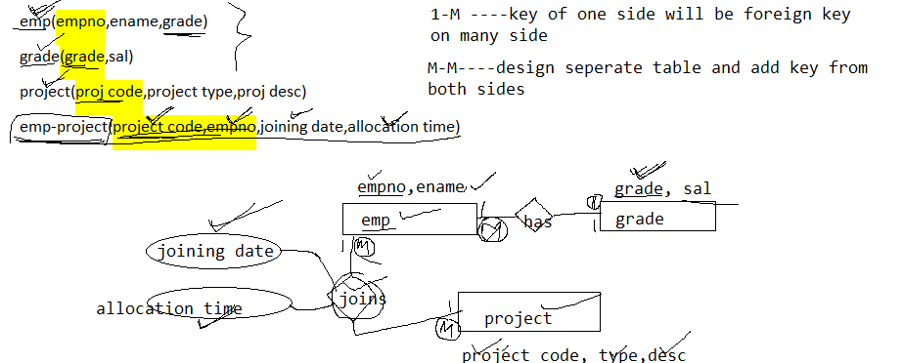

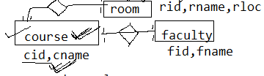



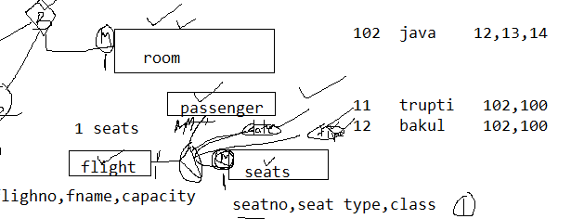

* **Orderno**
* **Orderdate**
* **Itemno**
* **Qty**
* **Price**
* **Cname**
* **Custno**
* **Email**
* **Orderamt**
* **Salespersonno**
* **Salespersonname**
* **Locationid ----------location from where item dispatched**
* **Location name**

**One customer can place many order**

**One order contains many items**

**One order will be managed by many salesperson**

**One order belong to one customer**

**One order can be dispatched from different location**

|  |  |  |  |  |  |  |  |  |  |  |  |  |
| --- | --- | --- | --- | --- | --- | --- | --- | --- | --- | --- | --- | --- |
| **Order no** | **orderdate** | **Item no** | **qty** | **price** | **cname** | **custno** | **email** | **amt** | **Salesperson no** | **sname** | **locid** | **lname** |
| **1** | **8 jun** | **1** | **1** | **1000** | **gayatri** | **1** | **g.cv** | **2050** | **100** | **x** | **11** | **delhi** |
| **1** | **8 jun** | **2** | **2** | **500** | **gayatri** | **1** | **g.cv** | **2050** | **101** | **y** | **11** | **delhi** |
| **1** | **8 jun** | **3** | **1** | **50** | **gayatri** | **1** | **g.cv** | **2050** | **100** | **y** | **12** | **mumbai** |
| **2** | **9 jun** | **1** | **2** | **900** | **yogesh** | **2** | **y.v** | **1060** | **102** | **z** | **14** | **Gujarath** |
| **2** | **9 jun** | **5** | **1** | **60** | **yogesh** | **2** | **y.v** | **1060** | **102** | **z** | **14** | **Gujarath** |
| **3** | **9jun** | **5** | **1** | **60** | **sagar** | **3** | **s.v** | **4200** | **100** | **x** | **100** | **x** |
| **3** | **9jun** | **10** | **2** | **70** | **sagar** | **3** | **s.v** | **4200** | **102** | **z** | **14** | **Gujarath** |
| **3** | **9jun** | **2** | **4** | **1000** | **sagar** | **3** | **s.v** | **4200** | **100** | **x** | **100** | **x** |
|  |  |  |  |  |  |  |  |  |  |  |  |  |

**1 1500**

**candidate key – ordered+itemid**

**to check whether in 2NF**

the table is in 1 NF

itemid

orderno-🡪order date, cname, cstno, amt, email,

itemid+ordered-> qty, buying price, salesman no, sname, locid, locname

order-item

|  |  |  |  |  |  |  |  |
| --- | --- | --- | --- | --- | --- | --- | --- |
| **Order no** | **Item no** | **qty** | **price** | **Salesperson no** | **sname** | **locid** | **lname** |
| **1** | **1** | **1** | **1000** | **100** | **x** | **11** | **delhi** |
| **1** | **2** | **2** | **500** | **101** | **y** | **11** | **delhi** |
| **1** | **3** | **1** | **50** | **100** | **y** | **12** | **mumbai** |
| **2** | **1** | **2** | **900** | **102** | **z** | **14** | **Gujarath** |
| **2** | **5** | **1** | **60** | **102** | **z** | **14** | **Gujarath** |
| **3** | **5** | **1** | **60** | **100** | **x** | **100** | **x** |
| **3** | **10** | **2** | **70** | **102** | **z** | **14** | **Gujarath** |
| **3** | **2** | **4** | **1000** | **100** | **x** | **100** | **x** |
|  |  |  |  |  |  |  |  |

|  |  |  |  |  |  |
| --- | --- | --- | --- | --- | --- |
| **Order no** | **orderdate** | **cname** | **custno** | **email** | **amt** |
| **1** | **8 jun** | **gayatri** | **1** | **g.cv** | **2050** |
| **2** | **9 jun** | **yogesh** | **2** | **y.v** | **1060** |
| **3** | **9jun** | **sagar** | **3** | **s.v** | **4200** |
|  |  |  |  |  |  |

1 tshirt 2000

1 mobile 35000 40000

1 jeans 3000

------ to check are they in 3NF

ordered+itemid-🡪salesman no-🡪 sname

ordered+itemid-🡪location no-🡪 lname

order-item

|  |  |  |  |  |  |
| --- | --- | --- | --- | --- | --- |
| **Order no** | **Item no** | **qty** | **price** | **Salesperson no** | **locid** |
| **1** | **1** | **1** | **1000** | **100** | **11** |
| **1** | **2** | **2** | **500** | **101** | **11** |
| **1** | **3** | **1** | **50** | **100** | **12** |
| **2** | **1** | **2** | **900** | **102** | **14** |
| **2** | **5** | **1** | **60** | **102** | **14** |
| **3** | **5** | **1** | **60** | **100** | **100** |
| **3** | **10** | **2** | **70** | **102** | **14** |
| **3** | **2** | **4** | **1000** | **100** | **100** |
|  |  |  |  |  |  |

salesperson

|  |  |
| --- | --- |
| **Salesperson no** | **sname** |
| **100** | **x** |
| **101** | **y** |
| **102** | **z** |
|  |  |

location

|  |  |
| --- | --- |
| **locid** | **lname** |
| **11** | **delhi** |
| **12** | **mumbai** |
| **14** | **Gujarath** |
| **100** | **x** |

oderid->custno🡪 cname

ordered->cust no🡪email

order table

|  |  |  |  |
| --- | --- | --- | --- |
| **Order no** | **orderdate** | **custno** | **amt** |
| **1** | **8 jun** | **1** | **2050** |
| **2** | **9 jun** | **2** | **1060** |
| **3** | **9jun** | **3** | **4200** |
|  |  |  |  |
|  |  |  |  |

customer

|  |  |  |
| --- | --- | --- |
| **cname** | **custno** | **email** |
| **gayatri** | **1** | **g.cv** |
| **yogesh** | **2** | **y.v** |
| **sagar** | **3** | **s.v** |